Tool 1: QA.tech
🔹 Tool Overview
QA.tech is an AI-based testing tool used for End-to-End (E2E) testing of B2B SaaS applications.
I selected this tool by keeping my current corporate work in mind, where I am already involved in E2E automation testing.

🔹 Key Features
- AI-supported E2E testing
- Handles complex B2B SaaS workflows
- Better stability with dynamic UI changes
- Reduces automation maintenance effort
- Validates flow across multiple systems
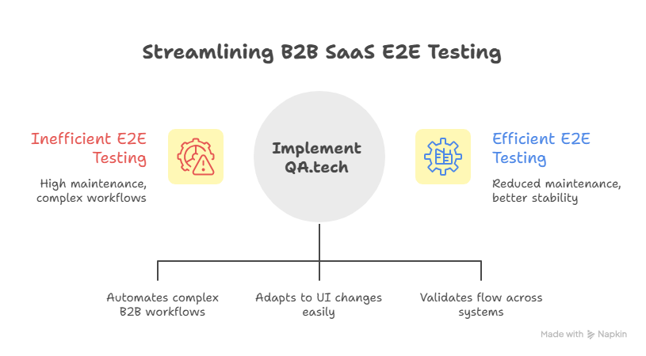

🔹 Use Cases
- End-to-End business flow testing
- Release and regression testing
- Validation of integrated systems
- Enterprise-level SaaS application testing

🔹 What I Will Do Using This Tool
As an automation tester, using QA.tech will do:
- Validate end-to-end business workflows
- Verify the flow from UI to backend and integrations
- Execute automation during regression cycles
- Analyze issues based on business impact 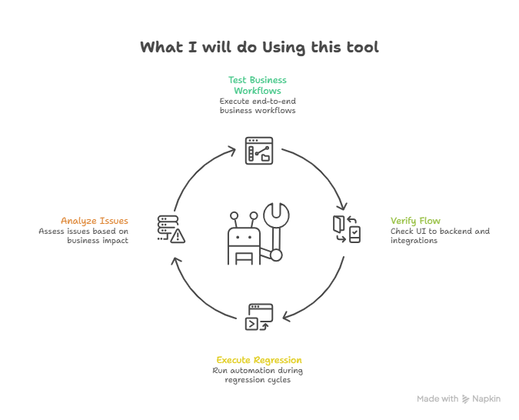

🔹 What I Want to Do
Using QA.tech, I want to:
- Further improve my E2E automation skills
- Reduce manual scripting and maintenance effort
- Focus more on business-level testing
- Grow with AI-based testing tools

🔹 Findings & Learnings
- AI-based tools make E2E testing more efficient
- In B2B SaaS, validating the complete flow is very important
- QA.tech is relevant for real corporate QA work

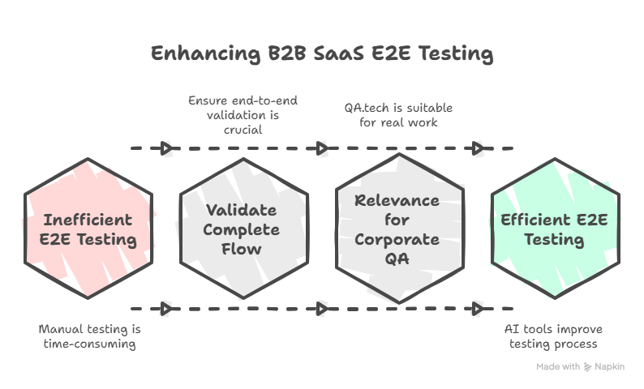

Tool 2: Google Antigravity
🔹 Tool Overview
Google Antigravity is an interactive Google experiment that demonstrates how a web interface behaves when gravity is applied. Instead of following a fixed layout, the elements of the Google search page fall and move freely, creating a unique and engaging visual experience.
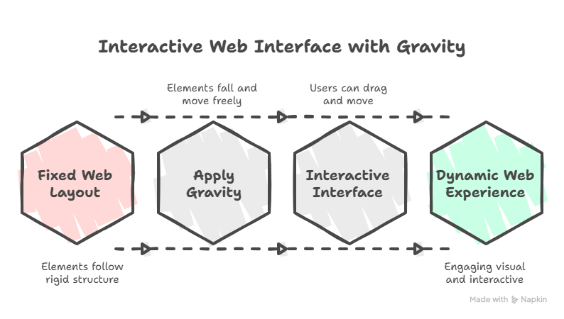

🔹 Key Features
• Interactive, physics-based simulation
• Web page elements react to gravity in real time
• Mouse interactions allow users to drag and move elements
• Dynamic and visually responsive behavior
• Easily accessible through a web browser
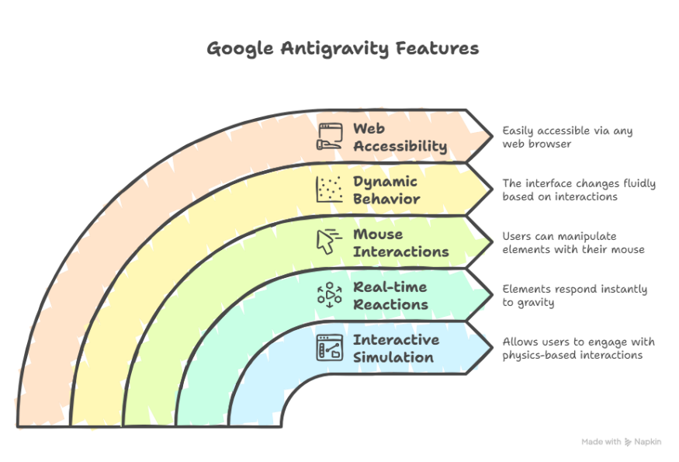

🔹 Use Cases
• Demonstrating interactive and dynamic UI behavior
• Understanding basic physics concepts applied to web interfaces
• Creative reference for UI/UX design experimentation
• Engagement-focused exploration of user interaction
• Visual demonstration of how interface elements respond to user actions
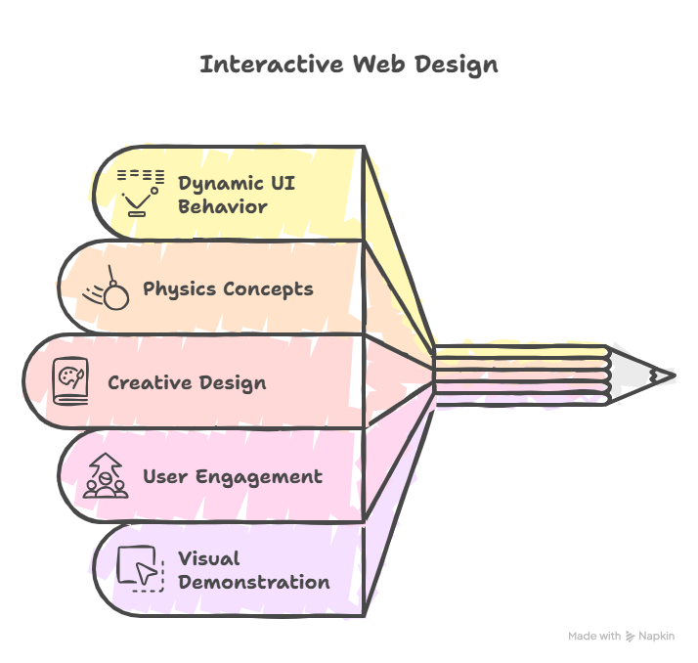

🔹 What We Did
• Accessed Google Antigravity through a browser
• Observed how the webpage layout changes when gravity is enabled
• Interacted with elements using mouse movements and drag actions
• Analyzed how motion and interaction impact the overall user experience

🔹 What I Want to Do
• Explore how similar interactive concepts can be applied in real applications
• Understand how motion and animation can improve user engagement
• Use such interactive ideas as reference for future UI or automation-related work
• Study how creative experimentation can influence user-centric design
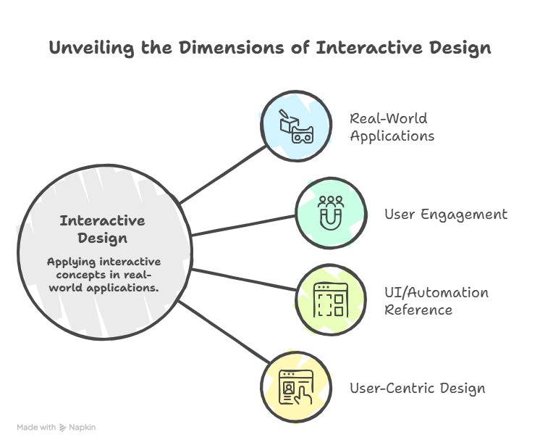

🔹 Findings & Learning
• Not all tools are built for productivity; some focus on creativity and exploration
• Interactive behavior plays a key role in improving user engagement
• Visual simulations help explain concepts more effectively than static designs
• Such experiments encourage innovation in interface design and interaction
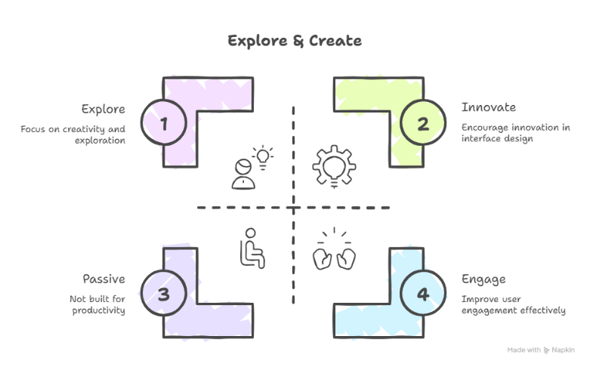

Tool 3: Pencil
🔹 Tool Overview
Pencil is a design tool that works directly inside the IDE and allows designing UI and generating UI code in the same environment. Instead of switching between design tools and development tools, Pencil helps keep design and coding in one place.
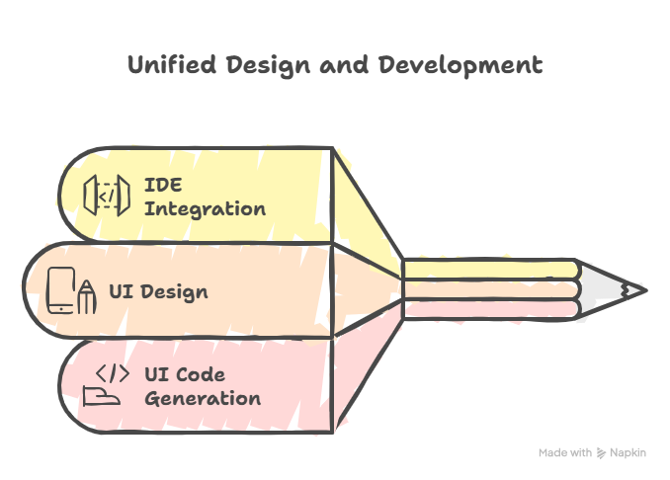

🔹 Key Features
• Works directly inside the IDE
• Allows UI design and code generation together
• Uses open design files stored in the code repository
• Supports version control, branching, and merging
• Generates HTML, CSS, and React code
• Supports Figma imports and editable styles

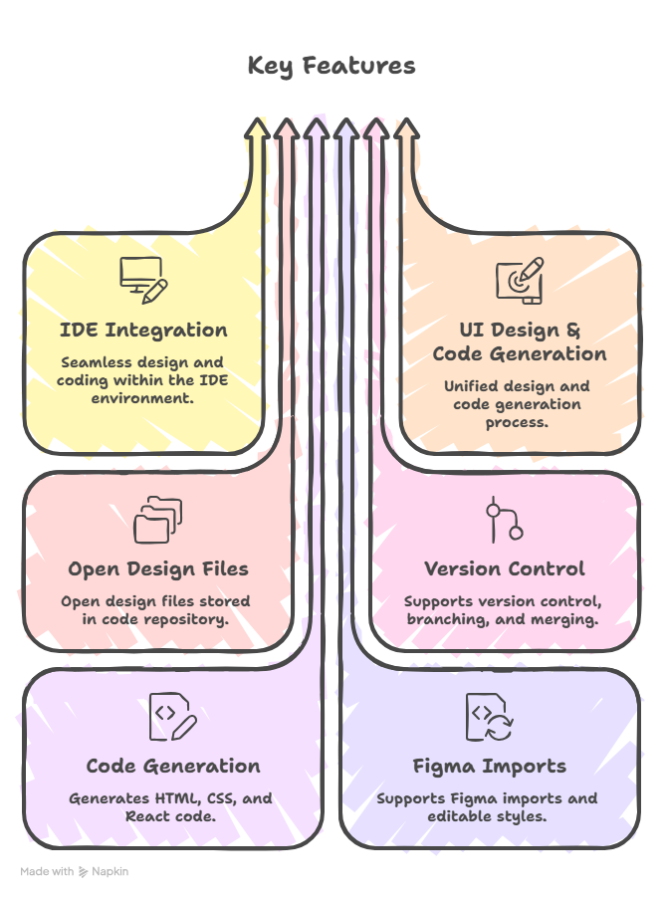

🔹 Use Cases
• Designing UI components during development
• Reducing gaps between design and implementation
• Faster UI creation for applications
• Team collaboration on design and code
• Maintaining consistency across UI components
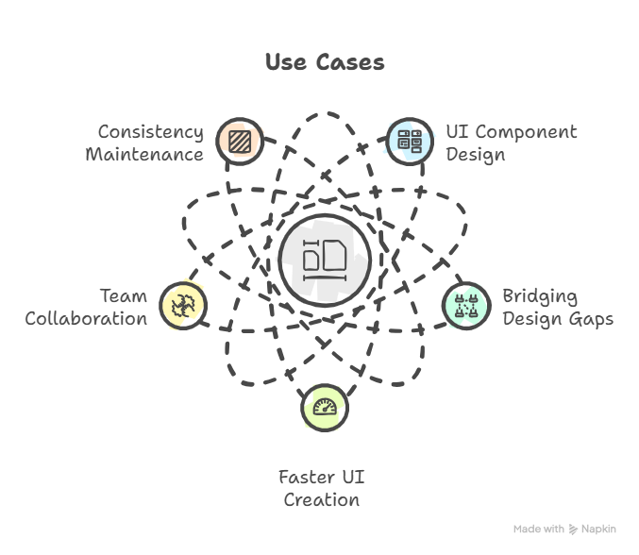

🔹 What We Did
• Reviewed Pencil as an IDE-based UI design tool
• Understood how UI screens and components can be generated
• Observed how design files are managed like code
• Analyzed how generated UI code can be used in development

🔹 What I Want to Do
• Use Pencil to design UI while coding
• Reduce dependency on separate design tools
• Speed up UI development using generated code
• Improve efficiency between design and development work
• Use it as a reference tool for UI structuring

🔹 Findings & Learning
• Designing within the IDE reduces context switching
• Version-controlled design files help in team collaboration
• UI code generation can save development time
• Pencil fits well with developer-focused workflows
